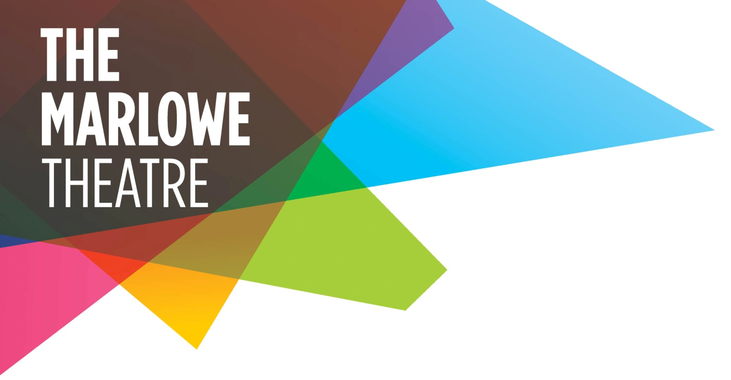

Press release
Monday 11 February 2013

THE MARLOWE Theatre’s first Resident Associate Company has been announced.
Canterbury-based Accidental Collective are Daisy Orton and Pablo Pakula. The pair met at the University of Kent, where they were both studying for a Master’s Degree in Drama. They were drawn together through a shared excitement for all the possibilities of theatre.
They soon began working together and set up Accidental Collective in 2005. Daisy, who comes originally from Yorkshire, and half-Spanish, half-German Pablo were keen to stay in Canterbury after graduating. Daisy said: “We were aware of a lack of similar artists and venues in the area but there is this idea that to be successful, you need to leave Kent. This isn’t the case.”
Accidental Collective went on to become a driving force in the local performance scene, setting up Pot Luck, a showcasing event, engaging in peer-to-peer support and curating The Marlowe Scratch Night. In 2009, Daisy and Pablo became the first Associate Theatre Company of the University of Kent’s School of Arts, and last year, they won the Canterbury Culture award in the category of Cultural Pioneer.

MF

-2-

As The Marlowe’s Resident Associate Company, Accidental Collective will co produce a brand new piece for The Marlowe Studio, will receive support from teams at the theatre (technical, marketing etc), free rehearsal space and a platform for their work to reach a larger audience.
Daisy said: “We have been working in the region for the past seven years and this new relationship with The Marlowe is a fantastic opportunity for us. We cannot wait to get started with our new show.”
The Marlowe’s Head of Creative Projects, Daniel Lipman, is delighted Accidental Collective are on board. He said: “This is an important development for our theatre, for the area, and, of course, for Daisy and Pablo. We are committed to recognising and then nurturing exciting new talent and this is the best possible start.”
Accidental Collective’s first performance will be here is where we meet, a performance inspired by John Berger’s book. It runs from Tuesday 18 to Saturday 22 June (8pm, plus a 2pm Thursday matinee) in The Marlowe Studio. Tickets are £7; to book, call The Box Office on 01227 787787 or go to marlowetheatre.com.
The next Marlowe Scratch Night is in The Studio at 8pm on Wednesday 10 July.
For more information about Accidental Collective, go to accidentalcollective.co.uk.

ENDS

